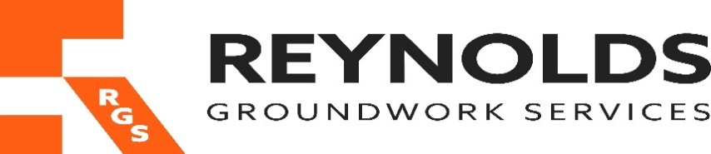

Health & Safety Policy Statement
Reynolds Groundwork Services Ltd are committed to the promotion of a safety culture, the elimination of hazards and the reduction of OH&S risks, the prevention of injury and ill health and providing a safe and healthy working environment for our employees and others who may be affected by our activities.
This includes a commitment to fulfilling legal and other OHSAS requirements and to achieving the highest levels of health and safety performance through continual improvement.
Health and safety is an integral part of our business and has equal status to other aspects of business performance. Appropriate financial and physical resources will therefore be provided to implement this policy.
We recognise that successful health and safety management can only be achieved with the support and commitment of our employees. All employees and key subcontractors will be actively encouraged to take ownership of health and safety and empowered to assist in decision making through the consultation and participation of workers and worker representatives. All employees and contractors will be made aware of their Health and Safety obligations and compliance with this policy is a condition of employment.
We will ensure that this policy is documented, implemented and maintained, and communicated and understood at all levels throughout the organisation.
Responsibilities for health and safety are defined in our Health and Safety Management System which conforms to the requirements of ISO 45001:2018. The day to day management of health and safety is a responsibility of managers at all levels but overall responsibility rests with the Managing Director. To assist with the implementation of our health and safety management system, professional external advice will also be obtained where necessary.
To facilitate continuous improvements in health and safety standards we will identify specific health and safety objectives. A programme for the objectives will be outlined with timescales and responsibilities. Progress towards the objectives will be closely monitored.
Periodic auditing of our Health and Safety Management System will be undertaken to ensure its continued suitability and effectiveness and we will review this policy at least annually and revise it as often as is appropriate.
This policy will be made available upon request to all interested parties.

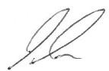

Signed Paul Reynolds Date 04/01/2024

