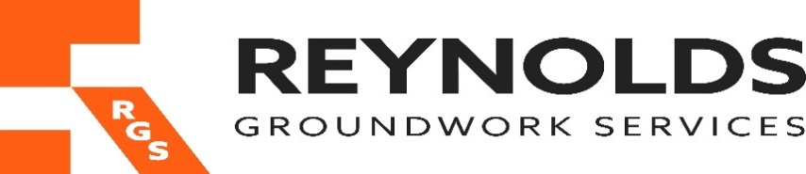

Slavery & Human trafficking Policy Statement

In-line with the Modern Slavery Act 2015 SLAVERY & HUMAN TRAFFICKING POLICY STATEMENT, Reynolds Groundwork Services Ltd is committed to preventing modern slavery and human trafficking from taking place within its business and supply chain and we place the same expectation on our suppliers.
The nature of our business requires that we work in conjunction with a range of suppliers, subcontractors, agencies, and professionals.
Reynolds Groundwork Services Ltd operates under the strictly regulated construction sector within the UK and follows the UK’s health and safety statutory and regulatory legislation.
The Directors believe that this significantly reduces the risk of contravention of the Modern Slavery Act 2015.
We have implemented several measures throughout our Integrated Management system, that reduces the risk of slavery and human trafficking within our supply chains.
These include:
- Most of our work is generally skilled and requires competent, capable skilled operatives who carry validated trade or professional qualifications, which are checked prior to work commencing or contract agreements.
- Work on our sites is always monitored by our own employees allowing a high degree of control and visibility of our own work.
- Material supplies that are used on our sites are generally sourced through UK distributors or UK companies within our supply chain, allowing strong commercial controls to be applied to encourage compliance with the Modern Slavery Act 2015.
- The following policies exist within our organisation which demonstrate our opposition to modern slavery:
- We ensure our suppliers are aware of our policies and encourage them to adopt the same high standards.
Our Company will work to promote awareness amongst its employees of modern slavery and human trafficking within the UK construction industry.
The company will ensure that their employee pay and conditions remain at a high standard, above those dictated by the Act. Any potential contravention will be dealt with seriously and investigated appropriately by the directors, as will any recommendations for improvement within the business.
Any whistle blowing or complaint by an employee will be supported and investigated through our formal grievance procedure.
The directors believe that the risk of failing to comply with the Modern Slavery Act 2015 is low, because of the following measures:
• All employees are on full written conditions of employment that are standardised and checked for compliance with the Act.
• All employees are paid at or above the “Living Wage”.
• No casual labour is employed.
• Unpaid work experience or internships are regulated through a standardised risk assessment.
Within Our Sub-Contractor Supply Chain Reynolds Groundwork Services Ltd will work to prevent modern slavery and human trafficking within our sub-contractor supply chains through reducing the risks and working to influence behaviours within our directly contracted sub-contractor organisations.
Any failure to address these issues that results in a contravention of the Act, a possible contravention, or a perceived contravention of the Act that could impact the reputation of Reynolds Groundwork Services Ltd may be investigated and result in a variety of actions, up to and including removal from our supply chain.
As part of our continuous improvement and compliance to our integrated management system, a review and amendment of standard terms of engagement to incorporate the requirements of the Act and requirements of Reynolds Groundwork Services Ltd Construction Limited is held annually at minimum, and each supplier is assessed before contract.
Large companies will be expected to provide their slavery and human trafficking statements for our records and review.
Our Purchasing department at Reynolds Groundwork Services Ltd will work to prevent modern slavery and human trafficking within our material supply chains by reducing the risks and working to influence behaviours within our directly contracted supplier organisations.
Any failure to address these issues that results in a contravention of the Act, a possible contravention, or a perceived contravention of the Act that could impact the reputation of Reynolds Groundwork Services Ltd may be investigated and result in a variety of actions, up to and including removal from our supply chain.
Due diligence processes relating to slavery and human trafficking As part of our efforts to monitor, manage and reduce the risk of slavery and human trafficking occurring within our business or supply chains, we adopt the following due diligence procedures:
Our processes aim to:
• Identify, monitor and manage areas of potential risk in our business and supply chains
• Scrutinise any identified areas of risk within our business and supply chains
• Adopt a zero-tolerance approach to slavery and human trafficking throughout the organisation and our supply chains
• Provide support and protection from detriment or disadvantage to any person who, in the public interest, raises genuine concerns amounting to a protected disclosure.
Risk and compliance assessments of key risks to contravention of the Act within our own businesses, our sub-contractor and material supply chain are carried out Annually.
This will identify the areas of concern and the mitigating acts that we will carry out this year and next to manage this risk as effectively as possible.
These risk assessments will be put together in conjunction with the senior employees as part of the training within our companies and will include those individuals who are responsible for procurement, management and control of our supply chains.
We ensure all employees are aware of the risks of modern slavery and human trafficking in our business and supply chains.
Detailed below are examples of the training programmes we have in place to enable our employees to identify and report any potential breaches of the organisations anti-slavery and human trafficking policies.
• Company policy, procedures and best practice guides are available on our company network, as part of our discussions on site, and in-house HSE and Compliance training.
This statement is made in accordance with section 54(1) of the Modern Slavery Act 2015 and constitutes Reynolds Groundwork Services Ltd Construction’s slavery and human trafficking statement.

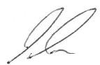

Signed Paul Reynolds - Managing Director Date 14/01/2024

